Charging Credit Cards with EdgePay Input (EPIN)

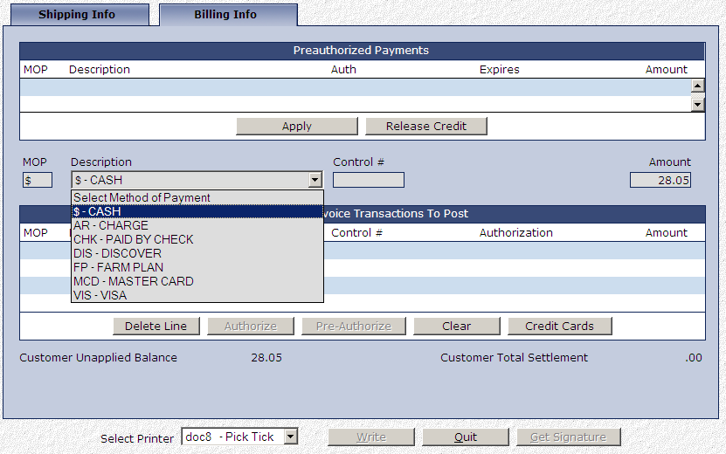
EdgePay Input (EPIN) is NetView Desktop’s credit card charging program. It can be accessed during the invoice writing process in Point-of-Sale (POS), Repair Order Maintenance (ROM), and Unit Sale (US) in order to let a customer pay with a credit card.
At the end of a ticket, after you have pressed the “Write” button, you can select a credit card as the method of payment. In the “Description” field, choose the type of card the customer wants to use from the drop-down menu. If the customer wants to pay with credit, select the type of credit card. If the customer wants to pay with debit, select “DEB-DEBIT CARD.” NOTE: You will be unable to switch between debit and credit in EdgePay Input.

Hit “Tab” or “Enter” on the keyboard until you pass through the dollar amount. EdgePay Input will open in a new window.

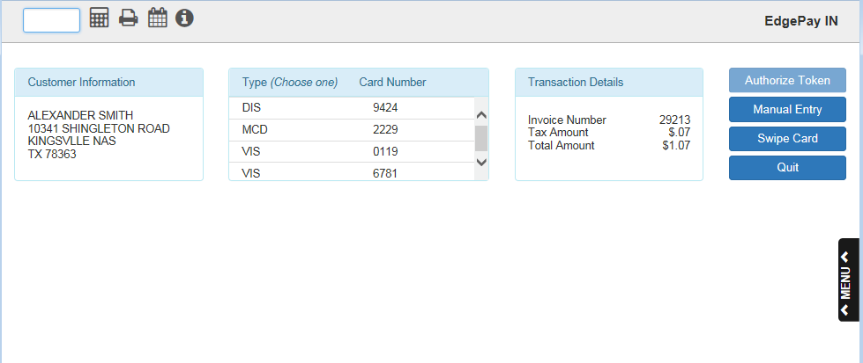

EdgePay Input—Layout

Customer Information
The Customer Information box displays the customer’s name and address.

Transaction Details
The Transaction Details box displays the details of the transaction being paid for: the invoice number, the tax amount, and the total amount.

Charging a Card in EdgePay Input
There are four different methods of charging a card: three for credit cards, and one for debit cards. Charge a card using the blue buttons on the right side of the window.

Credit Cards

Authorize Token
Use this method if the customer wants to pay with a token. NOTE: This button will not be accessible unless you are using a GPEP processor and the customer is paying with a public credit card.

Select the card you want from the list in the middle box. The chosen card will highlight in green. Click “Authorized Token.” The program will run the card automatically without requiring any manual action.

When the signature is required, the program will prompt you to ask the customer for their signature (see below). The customer must sign their name on the terminal to complete the transaction.
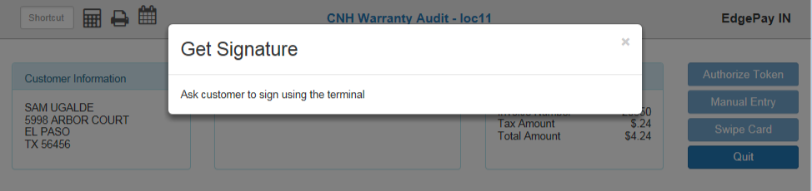

If the transaction is successful, a version of the following screen will display:

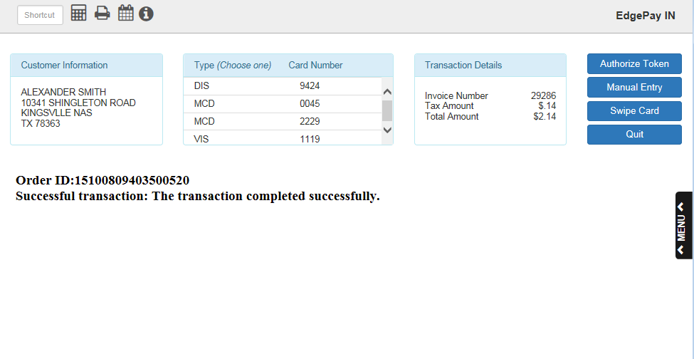

If the transaction is not successful, an error message will display. For example, if there is a problem with your merchant account, the following will display:
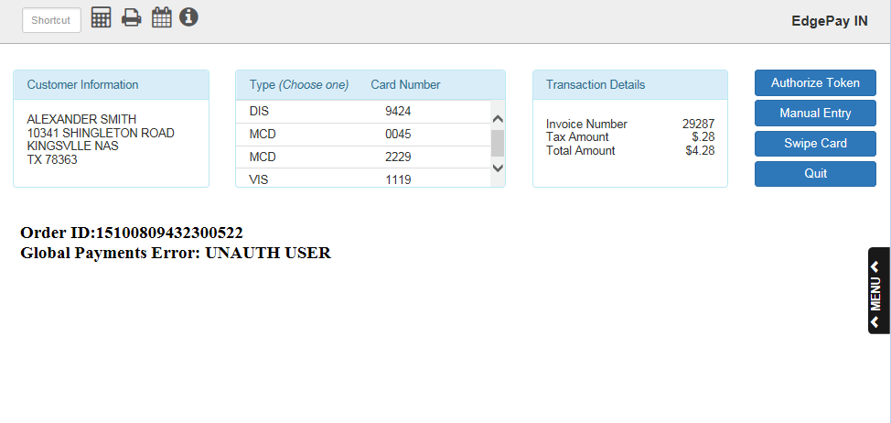

After a successful transaction, the program will return to the Invoice screen, where the transaction will then be listed in the box titled “Customer Invoice Transactions To Post.”

Manual Entry
Use this method to charge the card by manually entering its information. Click “Manual Entry.” The following screen will appear:

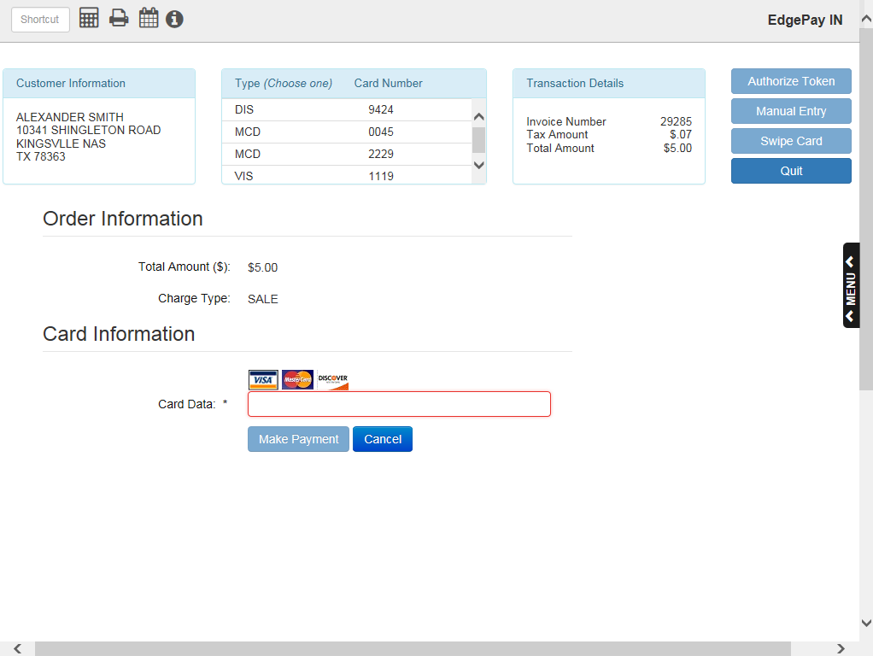

Begin typing the card number into the “Card Data” field. The field will then change to “Card Number” and reveal the remaining information fields, as seen below:

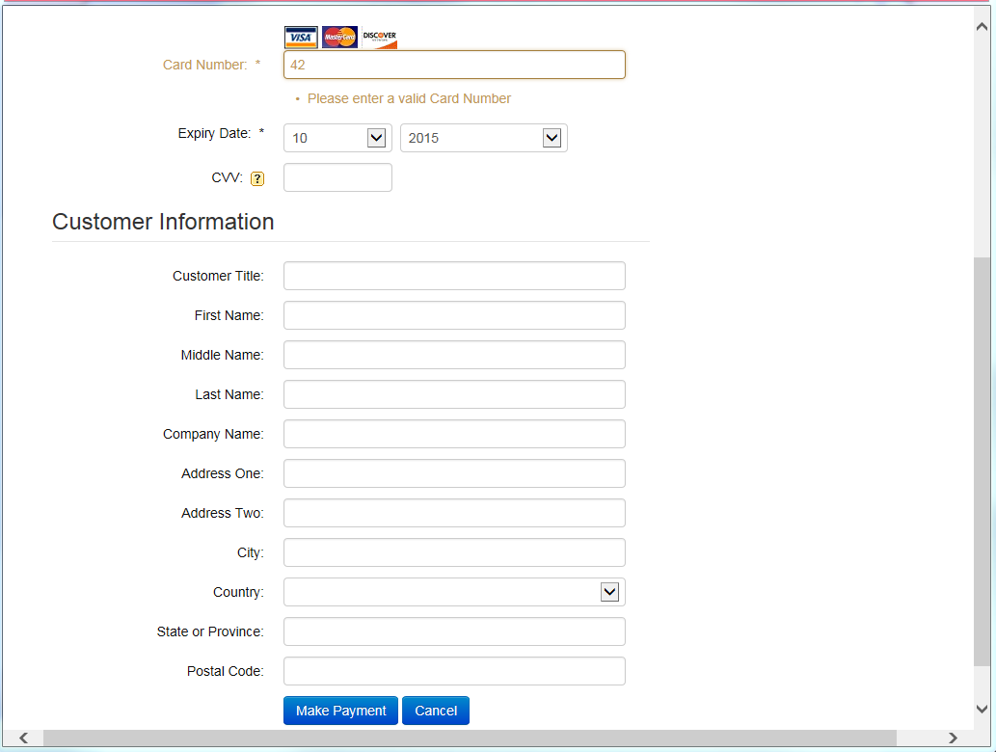

Finish typing in the card number. If the field accepts the card number, it will turn from red or yellow to green. Select the card’s expiration month and year from the drop-down menus next to “Expiry Date.” You can also enter the card’s CCV number and the customer’s information in the fields, though only the card number and the expiration date are required to complete the transaction.

Click “Make Payment.” The program will process the transaction and indicate that it was successful before returning to the Invoice screen. The transaction will then be listed in the “Customer Invoice Transactions To Post” box. If the transaction does not go through, the screen will show an error message.

Swipe Card
Use this method to charge the card using a credit card terminal. NOTE: This is the method to use when running a Chip transaction.

Click “Swipe Card.” The screen will bring up the following image reading “Processing Through Terminal”:
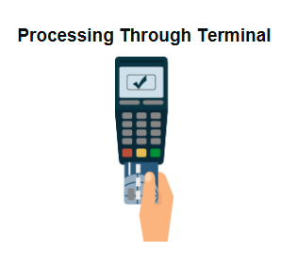
If for whatever reason the program is not properly connected to your terminal, an error message will appear. For example, “Connecting Remote Client Manager timeout” if you are not connected to Remote Client Manage, which runs your terminal software.

Process the card through the terminal. When the signature is required, the program will prompt you to ask the customer for their signature. The customer must sign their name on the terminal to complete the transaction. After the customer signs, the program will show either that the transaction was successful, or an error message indicating it was unsuccessful.

Once the transaction is successfully completed, the program will return to the Invoice screen, where the successful transaction will show in the “Customer Invoice Transactions To Post” box.

Debit Cards

Swipe Card
Use this method to charge the card using a credit card terminal. This is the only method by which you can charge a debit card.

Click “Swipe Card.” If you try to process the card through any other method, the following error message will appear:

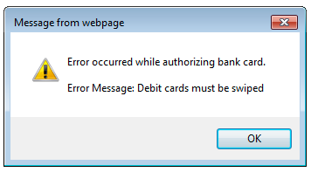

The program will bring up the “Processing Through Terminal” image. Process the card through the terminal. The program will then show either that the transaction was successful or an error message indicating it was unsuccessful.

It may also show a screen requesting you to ask the customer for their signature. If this is required for the transaction through the terminal, make sure they sign.

If the transaction is successful, the program will return to the Invoice screen and show the successful transaction in the “Customer Invoice Transactions To Post” box.

NOTE: Not all debit cards will render an authorization number with the transaction. Some may simply say “Authorized.”

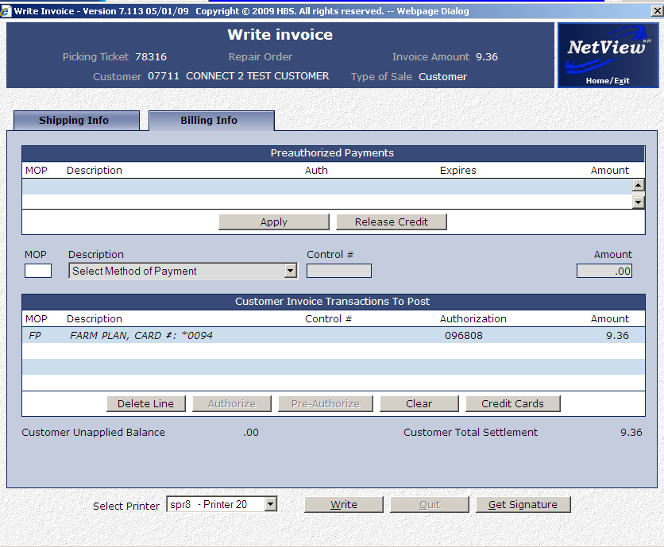

Double-Billing
In all cases, if you are about to double-bill a card for whatever reason, the system will automatically prevent you from doing so and show you an error message, such as “Duplicate Card Entry.” If this occurs, confirm with your OpenEdge Dealer Merchant Portal Account that the card has already been charged. If it has been charged, but the ticket is still open, one possible fix is to close to the customer’s A/R or cash account and make a one-sided entry on the General Ledger to reflect the charge.

Completing the Ticket
Once you have charged the card and been returned to the Invoice screen, click the “Write” button at the bottom of the screen to add the transaction to the ticket in POS.

Daily Transaction Log
Regardless of whether the transaction is successful or not, it will appear in the daily transaction log, which will automatically print out during the night after the end of a business day.

